Student ID: 102041946

Name: Thomas Casey

# Setup Screenshot

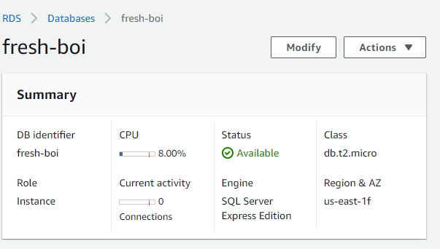

# Task 1 Screenshot

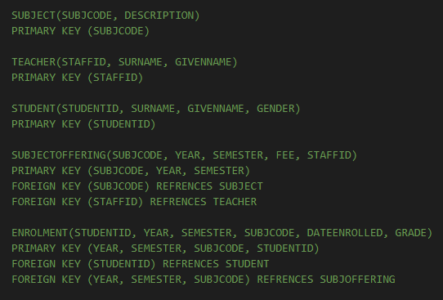

# Task 2 Screenshot

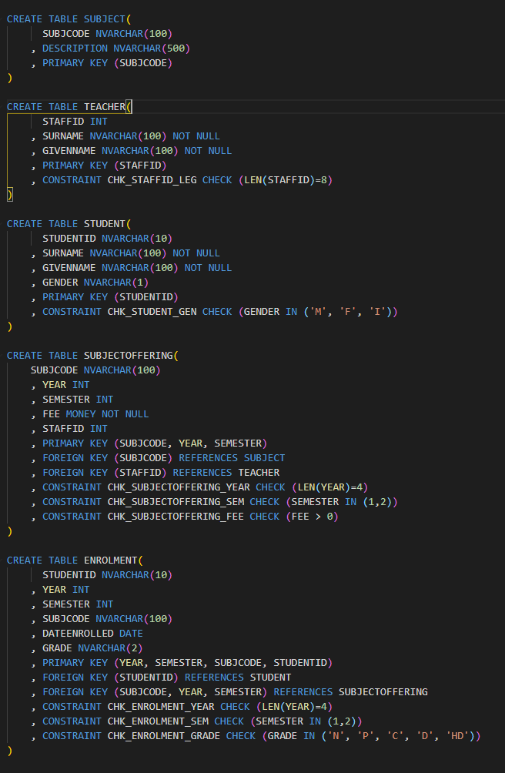

# Task 3 Screenshot

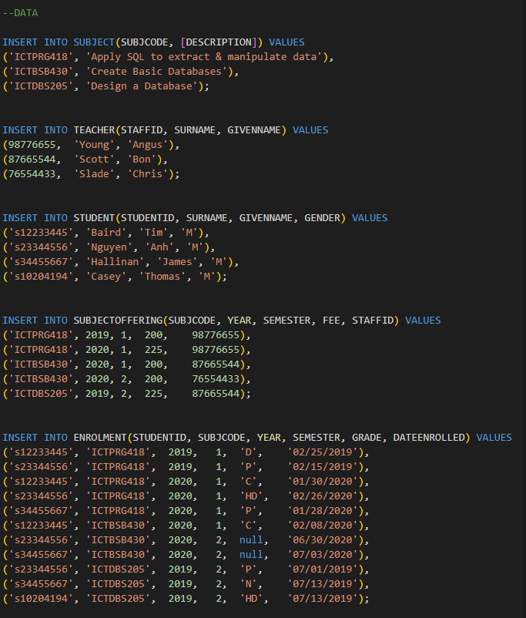

# Task 4 Screenshot

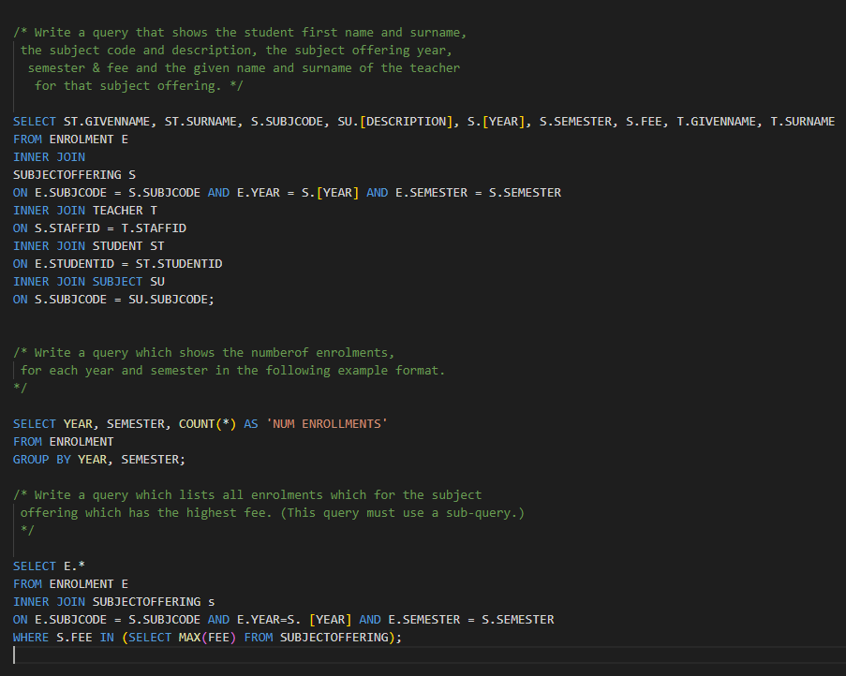

# Task 5 Screenshot

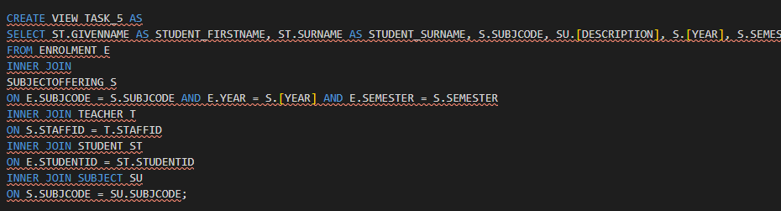

# Task 6 Screenshot

